

Microprocessor and Interfacing Lab

(CSC508)

# Practical Lab File

Submitted To: Submitted By

## Dr. Rajiv Verma Dipankar Yadav

Roll No.- 12111070

## Branch: CSE Semester: 5

Session: 2021-25

|  |  |  |
| --- | --- | --- |
| **Practical No.** | **Topic** | **Page Number** |
| 1. | Addition of two 8 bit numbers | 5 |
| 2. | Subtraction of two 8 bit numbers | 6 |
| 3. | Addition with a carry of two 8 bit numbers | 7 |
| 4. | Subtraction with a borrow of two 8 bit numbers | 8 |
| 5. | Multiplication of two 8 bit numbers using repeated addition | 9 |
| 6. | Multiplication of two 8 bit numbers using bit rotation | 10 |
| 7. | Division of two 8 bit numbers using repeated addition | 11 |
| 8. | Division of two 8 bit numbers using bit rotation | 12 |
| 9. | Addition of two BCD without using DAD | 13-14 |
| 10. | Maximum number in an array | 15 |
| 11 | Square of a 8 bit number | 16 |

Practical 1: - Write a program for addition of two 8 bit numbers

CODE:

MVI A,01H

MVI B,05H

ADD B

STA 0000H

HLT

OUTPUT:

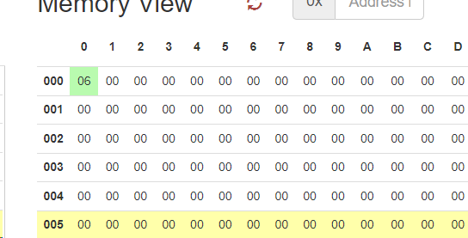

Practical 2: - Write a program for subtraction of two 8 bit numbers

CODE:

MVI A,11H

MVI B,05H

SUB B

STA 0000H

HLT

OUTPUT:

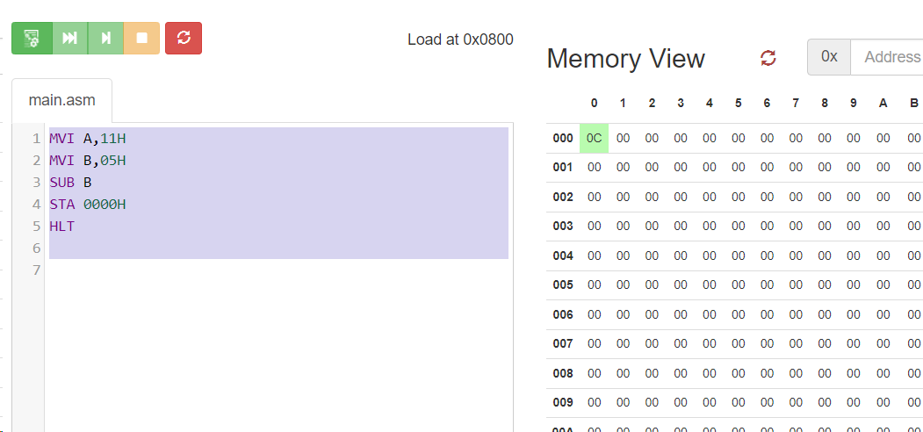

Practical 3: - Write a program for addition with a carry of two 8 bit numbers

CODE:

MVI A, 00H

MVI B,23H

MVI C,98H

MVI D,45H

MVI E, 22H

MOV A,C

ADD E

MOV C,A

STA 0061H

MOV A,B

ADC D

STA 0060H

hlt

OUTPUT:

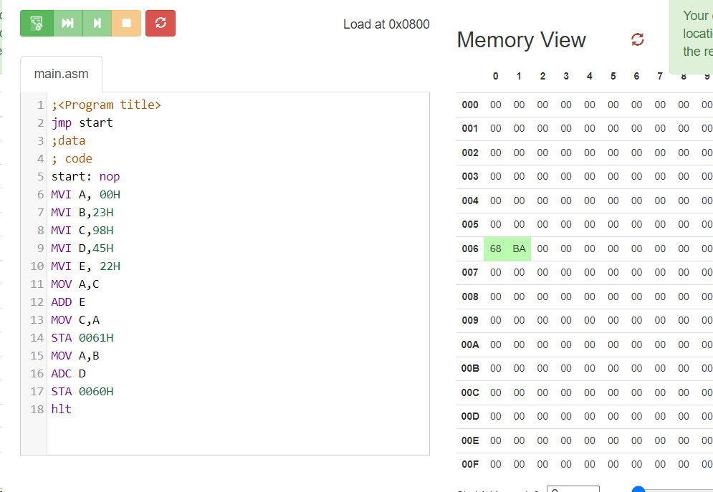

Practical 4: - Write a program for subtraction of two 8 bit numbers with borrow.

CODE:

MVI A, 8DH

MVI B, 7DH

MOV C, A

SUB B

JC SUBTRACT

SUBTRACT: STA RESULT

RESULT: DB 00H

HLT;

OUTPUT:

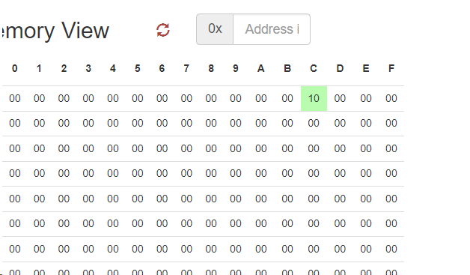

Practical 5: - Write a program for multiplication of two 8 bit numbers using repeated addition.

CODE:

MVI b,02h

MVI c,04h

MVI a, 00h

MVI d,00h

loop: add b

jnc skip

inr d

skip: dcr c

jnz loop

mov b,d

mov c,a

mov a,c

sta 0000h

hlt

OUTPUT:

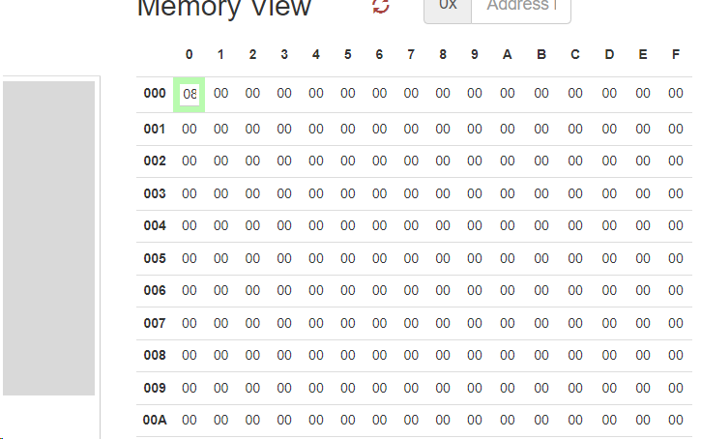

Practical 6: - Write a program for multiplication of two 8 bit numbers using bit rotation method

CODE:

MVI D,06H

MVI A,05H

LXI H,0000H

LOOP: RRC

JNC SKIP

DAD D

SKIP: XCHG

DAD H

XCHG

DCR C

JNZ LOOP

HLT

OUTPUT:

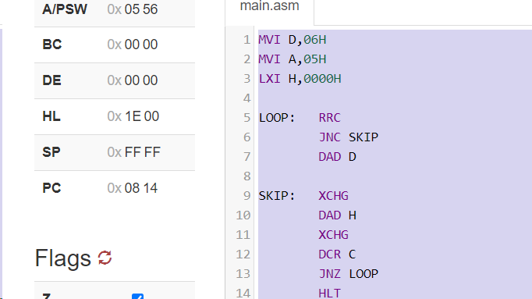

Practical 7: - Write a program for division of two 8 bit numbers by repeated addition method.

CODE:

MVI A, 27H

MVI B, 05H

MVI C, 00H

MVI D, 00H

LOOP: SUB B

JC DONE

INR C

JMP LOOP

DONE: MOV E, A

HLT

OUTPUT:

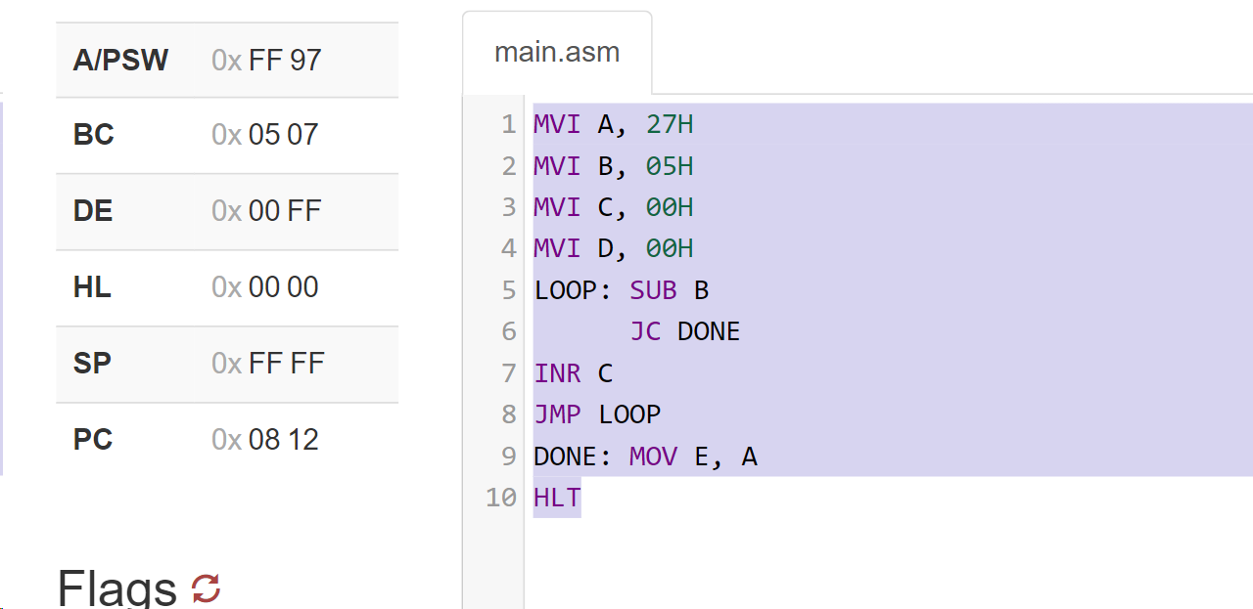

Practical 8: - Write a program for division of two 8 bit numbers using by bit rotation method.

CODE:

MVI E,00H;

LHLD 0008H;

LDA 0007H;

MOV B,A;

MVI C,08H;

NEXT:DAD H;

MOV A,E;

RLC

MOV E,A;

MOV A,H;

SUB B;

JC SKIP;

MOV H,A;

INR E;

SKIP:DCR C;

JNZ NEXT;

MOV A,E;

STA 0033H;

MOV A,H;

STA 0034H;

HLT;

OUTPUT:

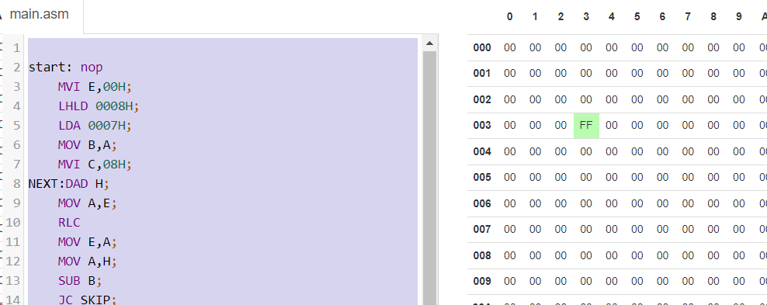

Practical 9: - Write an assembly language program to perform addition of 2 BCD numbers without using DAD in an 8085 microprocessor..

CODE:

LXI H,0000H

MOV B, M

INX H

MOV C,M

MVI A, 00H

MOV A,B

ADD C

MOV B,A

ANI 0FH

CPI 09H

JNC M

MOV A,B

JMP END

M: JNZ ABC

MOV A,B

JMP END

ABC: ADI 06H

MOV C,A

ANI F0H

MOV D,A

MOV A,C

SUB D

MOV C,A

MOV A,B

ANI F0H

ADD D

CPI 90H

JNC M2

ADD C

JMP END

M2: JNZ XYZ

ADD C

JMP END

XYZ: ADI 60H

ADD C

MOV B,A

MVI A,01H

STA 0001H

MOV A,B

JMP END

END:STA 0002H

HLT

Output:

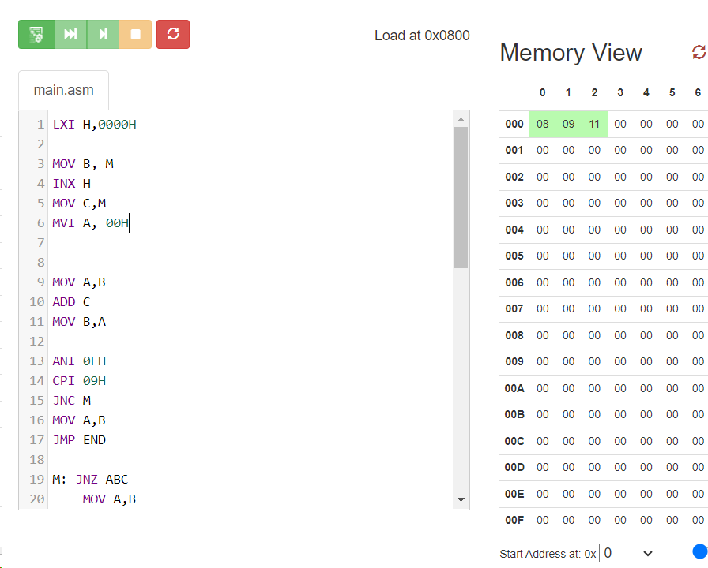

10. Write an assembly language program to find the maximum value in an array in an 8085 microprocessor.

Code:

LXI H,0001H

LDA 0000H

MOV D,A

MVI A,0H

LOOP:CMP M

JNC VALUPDT

MOV A,M

VALUPDT:INX H

DCR D

JNZ LOOP

MOV M,A

HLT

Output: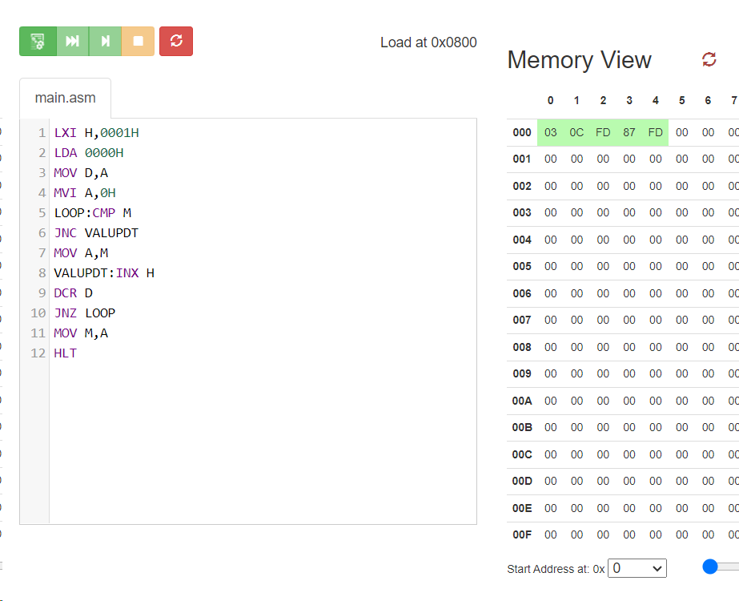

11. Write an assembly language program to find the square of an 8 bit number in an 8085 microprocessor.

Code:

LHLD 0000H

XCHG

LDA 0000H

LXI H,0000

MVI C,08H

Loop:DAD H

RAL

JNC Ahead

DAD D

Ahead:DCR C

JNZ Loop

SHLD 0001H

HLT

Output:

